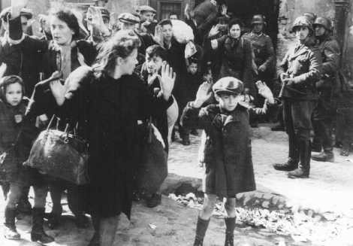
The Little Boy with His Hands up
Yala Korwin
Your open palms raised in the air
like two white doves
frame your meager face,
your face contorted with fear,
grown old with knowledge beyond your years.
Not yet ten. Eight? Seven?
Not yet compelled to mark
with a blue star on white badge
your Jewishness.
No need to brand the very young.
They will meekly follow their mothers.
You are standing apart
against the flock of women and their brood
with blank, resigned stares.
All the torments of this harassed crowd
are written on your face.
In your dark eyes—a vision of horror.
You have seen Death already
on the ghetto streets, haven’t you?
Do you recognize it in the emblems
of the SS-man facing you with his camera?
Like a lost lamb you are standing
apart and forlorn beholding your own fate.
Where is your mother, little boy?
Is she the woman glancing over her shoulder
at the gunmen by the bunker’s entrance?
Is it she who lovingly, though in haste,
buttoned your coat, straightened your cap,
pulled up your socks?
Is it her dreams of you, her dreams
of a future Einstein, a Spinoza,
another Heine, or Halevy
they will murder soon?
Or are you orphaned already?
But, even if you still have a mother,
she won’t be allowed to comfort you
in her arms.
Her tired arms loaded with useless bundles
must remain up in submission.

Alone you will march
among other lonely wretches
toward your martyrdom.
Your image will remain with us
and grow and grow
to immense proportions,
to haunt the callous world,
to accuse it, with ever stronger voice,
in the name of the million youngsters
who lie, pitiful rag-dolls,
their eyes forever closed.

