[](http://www.google.com/imgres?q=birthday+balloons&um=1&hl=en&safe=active&sa=N&rlz=1T4GGIE_enUS443US445&biw=1280&bih=673&tbm=isch&tbnid=GrWBu5B7wszIuM:&imgrefurl=http://www.dailyclipart.net/clipart/category/birthday-clip-art/&docid=vR8yQpzYTp9cGM&w=340&h=570&ei=KEyTTp7DEMWssQKVn7X7Dw&zoom=1)

**Point of View**

**Foreshadowing** List some items and sentences in the story that foreshadow the ending.

**Irony: where do we see irony in this story?**

Where do we see irony in this story? 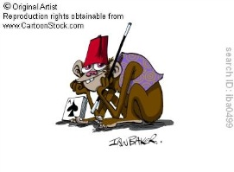

**Motif** What are some motifs we see in this short story?

How does the setting affect the story?

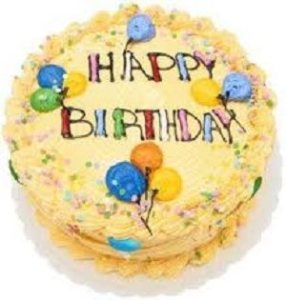

**Setting**

What is the setting of this story?

By Liliana Heker

The Stolen Party