[](http://www.google.com/url?sa=i&rct=j&q=tom+robinson+to+kill+a+mockingbird&source=images&cd=&cad=rja&docid=Xd7PdLbS3rX7zM&tbnid=EGwleHCOc7M3KM:&ved=0CAUQjRw&url=http%3A%2F%2Ftorrestkam.weebly.com%2Ftom-robinson.html&ei=B55-UafSEYParAHV8IHIAw&bvm=bv.45645796,d.aWM&psig=AFQjCNEXjDK-bMsdKUyhtZYg-YzG5lpB5A&ust=1367338878515956)

Thoughts or fears….

Feelings about the situation

Feelings about others

**Tom Robinson**

[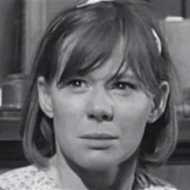](http://www.google.com/url?sa=i&rct=j&q=mayella+ewell&source=images&cd=&cad=rja&docid=vQFdEK4F_cuy3M&tbnid=K_t_GM0nUTHJ9M:&ved=0CAUQjRw&url=https%3A%2F%2Ftwitter.com%2FMsMayellaEwell&ei=zZx-UYDAFcPfrAGM3IGwDQ&bvm=bv.45645796,d.aWM&psig=AFQjCNFn9CTTqPxMNC0-r6ZVStvxmXrcug&ust=1367338541108028)

**Mayella Ewell**

Feelings about others

Feelings about the situation

Thoughts or fears….