Foil
Definition:
The term ‘foil’ refers to a literary device where the author creates a character whose primary purpose is to create a contrast to another character by laying emphasis or drawing attention to the latter’s traits and characteristics through the former’s obviously contradictory ones.
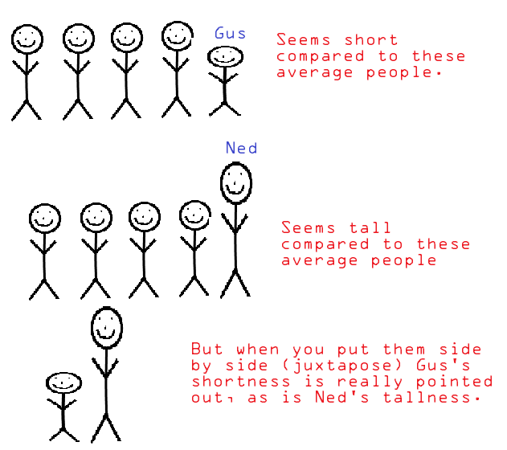

Compare and Contrast Ender to Peter.
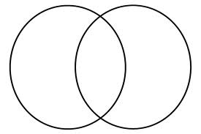
What traits does Peter have that FOIL traits of Ender’s?
Peter
Ender

