Carousel Activities:
Set up three “Carousel” each with three stations.
- Split the class into 3 groups. Then divide the groups into 3 sub-groups (ideally 2-4 students in each sub group). For fun you can name each group and sub group.
- Each sub group will travel to each station (3 stations for each group) and are responsible for answering that stations questions and completing the activity.
- When each station has been “attended” by each sub group, have the sub groups come together with the rest of their group and discuss the questions and the station activities.
- You can then discuss the topics as a whole class. (optional)
Ending Group Activity: Create a characterization chart for one of the Wiggin children: Peter, Violet, or Ender.
They can either draw the character on a giant poster board and put quotes that support their characterization of the child, or fill out chart below.
 | Text from the book | Inferences we can make about the character based on this information.
Appearance
Actions
Words
What others say about them
Thoughts

Station 1
Compare the technology in the book to the technology we live with today. How would this comparison have been different if done when the book was written in 1985. Show this answer with visuals-no sentences or paragraphs.
For Example: 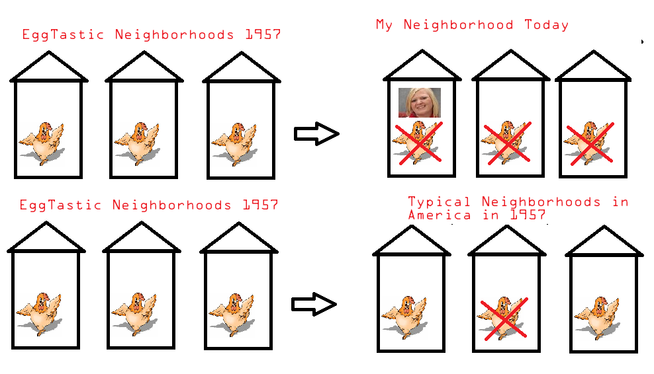

Station 2:
Each chapter begins with a conversation between two people. Who are these people? What do we learn from these people? Why does Orson Scott Card begin each chapter with them?
With your group re-write one of the opening sequences in chapters 1, 2, or 3 in the same point of view which the rest of the novel is written or incorporate that information into the chapter with the same point of view.
How does this change the experience or understanding of the reader?

Station 3:
What role does Eugenic play in the novel’s society? How does eugenics affect the Wiggin family?
- Brainstorm about the Wiggins children and their genetic /personality traits.

Traits of this Character | Inherited Traits | Traits Acquired | Not Sure where traits came from
Peter
Violet
Ender

Why did the government want Ender’s parents to have him, a Third? What traits were they hoping he would get? What traits did they find undesirable in Peter? What traits did they find undesirable in Violet?

