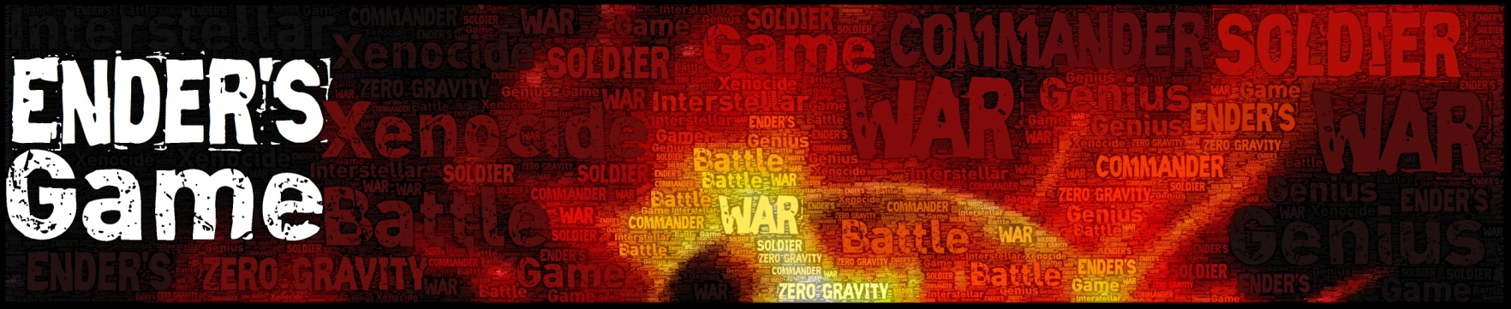

Character Log

Name: Period:

Ender Wiggin

Traits, Characteristics, and Important Facts (Who is Ender and what is he like?) -

Memorable Quote #1 (something Ender said or thought) - Page #

What does this quote reveal about Ender’s character?

Memorable Quote #2 (something Ender said or thought) - Page #

What does this quote reveal about Ender’s character?

In what ways does Ender change over the course of the story?

Valentine Wiggin

Traits, Characteristics, and Important Facts (Who is Valentine and what is she like?) -

Memorable Quote (something Valentine said or thought) - Page #

What does this quote reveal about Valentine’s character?

In what ways does Valentine change over the course of the story?

Peter Wiggin

Traits, Characteristics, and Important Facts (Who is Peter and what is he like?) -

Memorable Quote (something Peter said) - Page #

What does this quote reveal about Peter’s character?

In what ways does Peter change over the course of the story?

Bernard

Traits, Characteristics, and Important Facts (Who is Bernard and what is he like?) -

Memorable Quote (something Bernard said) - Page #

What does this quote reveal about Bernard’s character?

In what ways does Bernard change over the course of the story?

Alai

Traits, Characteristics, and Important Facts (Who is Alai and what is he like?) -

Memorable Quote (something Alai said) - Page #

What does this quote reveal about Alai’s character?

In what ways does Alai change over the course of the story?

Bonzo Mardid

Traits, Characteristics, and Important Facts (Who is Bonzo and what is he like?) -

Memorable Quote (something Bonzo said) - Page #

What does this quote reveal about Bonzo’s character?

In what ways does Bonzo change over the course of the story?

Rose the Nose

Traits, Characteristics, and Important Facts (Who is Rose and what is he like?) -

Memorable Quote (something Rose said) - Page #

What does this quote reveal about Rose’s character?

In what ways, if any, does Rose change over the course of the story?

Petra Arkanian

Traits, Characteristics, and Important Facts (Who is Petra and what is she like?) -

Memorable Quote (something Petra said) - Page #

What does this quote reveal about Petra’s character?

In what ways does Petra change over the course of the story?

Dink Meeker

Traits, Characteristics, and Important Facts (Who is Dink and what is he like?) -

Memorable Quote (something Dink said) - Page #

What does this quote reveal about Dink’s character?

In what ways does Dink change over the course of the story?

Bean

Traits, Characteristics, and Important Facts (Who is Bean and what is he like?) -

Memorable Quote (something Bean said or thought) - Page #

What does this quote reveal about Bean’s character?

In what ways does Bean change over the course of the story?

Mazer Rackham

Traits, Characteristics, and Important Facts (Who is Mazer and what is he like?) -

Memorable Quote (something Mazer said) - Page #

What does this quote reveal about Mazer’s character?

In what ways does Mazer change over the course of the story?

Colonel Graff

Traits, Characteristics, and Important Facts (Who is Graff and what is he like?) -

Memorable Quote (something Graff said) - Page #

What does this quote reveal about Graff’s character?

In what ways does Graff change over the course of the story?

Major Anderson

Traits, Characteristics, and Important Facts (Who is Anderson and what is he like?) -

Memorable Quote (something Anderson said) - Page #

What does this quote reveal about Anderson’s character?

In what ways does Anderson change over the course of the story?

