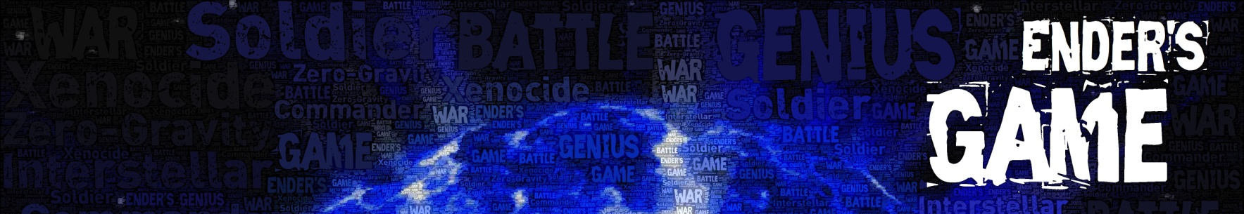

Bean’s Assignment

Your Name: Your Group Member’s Names:

“I need you to be clever, Bean. I need you to think of solutions to problems we haven’t seen yet. I want you to try things that no one has ever tried because they’re absolutely stupid.”
“Why me?”
“Because even though there are some better soldiers than you in Dragon Army—not many, but some—there’s nobody who can think better and faster than you.” Bean said nothing. They both knew it was true.
(Ender’s Game – Chapter Eleven)

Your Individual Assignment:
Come up with four ideas for crazy things that Ender could have his army do (or that Bean could have his toon do) that have most likely never been done in the history of Battle School. Don’t be afraid to come up with crazy ideas—in fact, the crazier the better. Work on your individual five ideas, write a brief description or explanation of each, and then be ready to share them with your group.

Your Group Assignment:
Now take turns sharing your five ideas. Each time a person shares an idea, discuss it as a group. DON’T discuss whether it’s a good idea or a bad idea—remember, Ender specifically asked for ideas that were “stupid.” Instead, talk about what the effect of the idea would be—what would happen if we tried this idea in the battleroom? Don’t ask, “Would this work or not?” Instead, ask, “What would it look like if we did this during practice? What would it look like if we tried this during a battle against another army?”

Then, after you’ve discussed all of the ideas, go back and pick the four ideas from the entire group that sound the most promising (and, preferably, the most insane.) Describe the four ideas below:

What is the idea? What would the army or toon do?
Why does this idea sound promising?

What is the idea? What would the army or toon do?

Why does this idea sound promising?
What is the idea? What would the army or toon do?

Why does this idea sound promising?
What is the idea? What would the army or toon do?

Why does this idea sound promising?

